# QUESTION # 1

**#include <iostream>**

**using namespace std;**

**int main ()**

**{**

**int a[10],in,ix;**

**int min=INT_MAX;**

**int max=INT_MIN;**

**for (int b=0;b<10;b++)**

**{**

**cout <<"Enter "<<b+1<<" value : ";cin>>a[b];cout<<endl;**

**if (min>a[b])**

**{**

**min=a[b];**

**in = b;**

**}**

**if (max<a[b])**

**{**

**max=a[b];**

**ix=b;**

**}**

**}**

**cout << "Maximum Value is : "<<max<<" at index "<<ix<<endl;**

**cout << "Minimum Value is : "<<min<<" at Index "<<in<<endl;**

**return 0;**

**}**

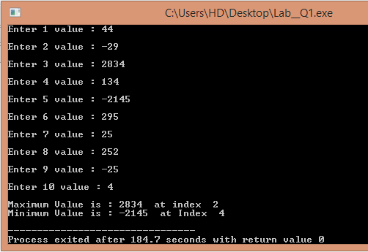

# QUESTION # 2

**#include <iostream>**

**using namespace std;**

**int main ()**

**{**

**float a[10],c=0;**

**for (int b=0;b<10;b++)**

**{**

**cout << "Enter "<<b+1<<" Value : ";cin>>a[b];cout << endl;**

**c+=a[b];**

**}**

**cout << "Sum : "<<c<<endl;**

**cout << "AVERAGE : "<<c/10<<endl;**

**return 0;**

**}**

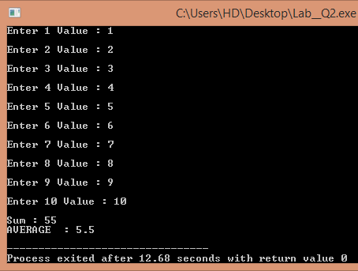

# QUESTION # 3

**#include <iostream>**

**using namespace std;**

**int main ()**

**{**

**int A[5],b,c;**

**for (int a=0;a<5;a++)**

**{**

**cout << "Enter "<<a+1 << " Value : ";cin>>A[a];**

**}**

**cout <<endl;**

**cout << "Enter a Value : ";cin>>b;**

**cout <<endl;**

**for (int a=0;a<5;a++)**

**{**

**if (b==A[a])**

**{**

**cout << "Value is at : "<< a <<endl;**

**c++;**

**}**

**}**

**if (c==0)**

**{**

**cout << "Value is not available ! "<<endl;**

**}**

**return 0;**

**}**

